Cinema City

Database class project 2023/2024

|  |  |  |  |  |
| --- | --- | --- | --- | --- |
| Student Name in English | Student Name in Arabic | Student ID | Section | Work percentage |
| Yamama Ashayer |  |  | 11:00- 12:00 | 50% |
| Diala Shami |  |  | 11:00- 12:00 | 50% |
|  |  |  |  |  |

Date/time

---------------------------------------------This section is intended for the Instructor---------------------------------------

|  |  |
| --- | --- |
| **Topic** | **Mark** |
| Project Requirements and Modeling |  |
| Correctness of Database mapping |  |
| Functional Dependency and Normalization |  |
| Project Tools |  |
| Project Discussion |  |
| Project Completeness |  |
| Project Output Results or reporting (JasperReport, charts, graphs, etc.) |  |
| Project Administration and Management |  |
| Project Report |  |
| Project Idea |  |
| Project Complexity |  |
|  |  |
|  |  |
|  |  |
|  |  |

**Table of contents**

**Abstract** …...………………………………………………………………………...…...

**Introduction** ………………………………………………………………………...…...

**Cinema City Data Requirements** ………………………………………………...……

**UML representation for Cinema City requirements** …………………………...…...

**Cinema City Tables** ………………………………………………………………...…...

**Cinema City GUI**.…………………………………………………………………….......

**Cinema City main frames ………………………………………………….…...…**

Customers Registration **..…………………………………..……………...**

Admins Registration **......…………………………………..……………...**

**Housed Frame ..………...…......…………………………………..……………...**

**Types of Movies frame ……...……………………………....……………...…......**

Action Movies **…………..…………………………………..………….......**

superhero Movies **……...……………………………………..…...……..….**

Horror Movies **………………………………..……………..……..…...….**

Animation Movies **………………………………………..……....…….**

Mysterious Movies **…..………………………………………..……….…….**

Disnep Movies **…..………………………………………..……….…….**

**The Halls frame …………………………………………………………………....**

**Food List frame ……...………………………………………………………….....**

Food **………………….………………………………………..………...…….**

Drinks **………………….………………………………………..……...…..….**

**Tickets frame …………………………………………………………………........**

**Conclusion ……………………………………………………………….……………….**

**References ………………………………………………………………………………...**

**Abstract**

Cinema City is a project for a Cinema Data-base, it allows the managers of the cinema to arrange all the data of the halls, movies, food, drinks, customers, and staff into tables and columns. Additionally, it allows the managers to ease-of-access to the data of the cinema.

**Introduction**

Welcome to our project (Cinema City) database, we worked on the staff of (cinema city), movies, halls, tickets, food court, and several things. Every user has to create an account before having access to move between the frames.

There are differences between the admin and customer access at the cinema. Admins have more features than customers, they can add movies, food, drinks, tickets, and halls. Additionally, admins can observe the customers' frames, to be sure that everything is user-friendly and all frames don't have any problems.

Cinema City consists of lists of movies, tickets, food, and drinks.

**Cinema City Data Requirements**

The manager controls the entire list of films. He can modify it or add a new film to it, and everything concerns the list of films .The manager over the employees supervises all the employees’ work and all their information. He can modify the information of any employee, or delete any of his information. He can add a new employee to the employee list. The manager can also supervise and manage the menu completely. He can modify the prices of food and drinks, and he can add a new item to the menu .The director supervises the halls and periodically inspects them and the staff for each hall . The manager supervises the tickets on a regular basis, counts their number, and can add new tickets for a new movie that may be shown in the future.

The staff of cinema city consists of a huge number of employees, each one has its unique name, unique ID number, gender, birthdate, his / her salary, age, working hours and days, address, phone number, and his / her direct supervisor. Each group of the employees controls a different section in the cinema city such as the halls, food court, and cache.

Cinema city shows a list of movies, there are different types of movies, each movie has a unique name, description, hall ID number, type of movie, date, screening time

Cinema city has a food court that contains different types of food and juices, the whole amount needed, the rest amount, and the price of each type of food and juices.

Halls in cinema city have a unique ID number, hall reservation times, and the number of seats in each hall. Each seat has a unique number that is mentioned in a ticket that the client buys.

Movies in cinema city have tickets that the client can buy to watch this movie. Each group of tickets is for a certain movie with a specific number of tickets for each one. Every ticket has a unique number, name of the movie, date, time, hall number, the remaining number of tickets and the price of each one.

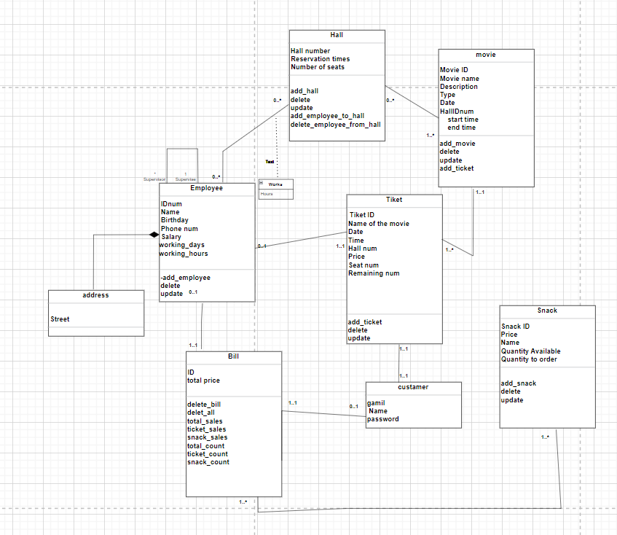**UML representation**

**for Cinema City Data Requirements**

**Cinema City Tables**

Tables are distinct from each other, there is no repetition in data of movies, halls, tickets, customers, employees, drinks, and food.

**Cinema City GUI**

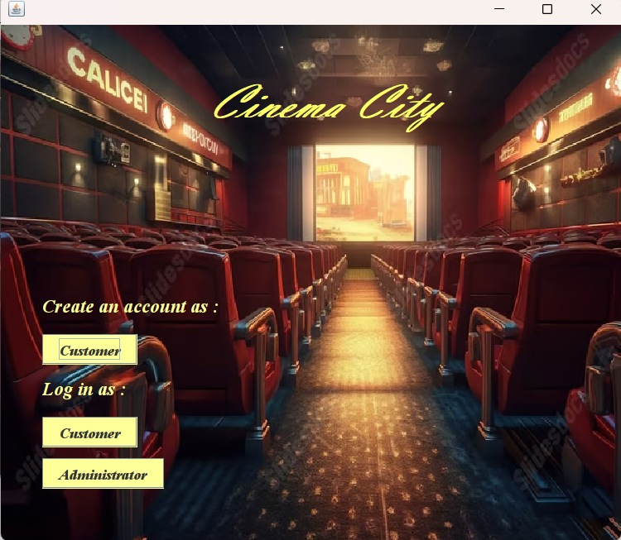**Cinema City main frames**

(Create) Frame

Create Frame, is the main frame in Cinema City GUI, in this frame If the customer doesn't have any account, he will click on (Customer) button to create a new account by opening the (Create account as an Customer) frame.

Entry as a administrator is through two managers who have been entered into the Database. No one else can enter the Database except them.

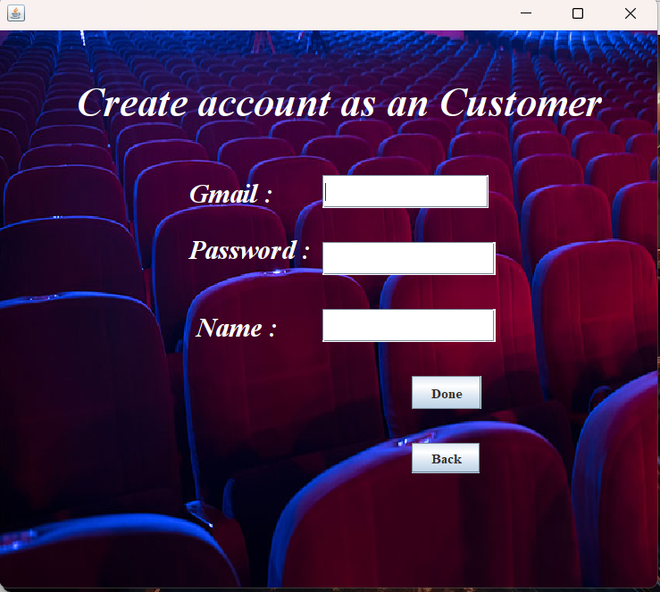**Customers Registration**

in this frame the customer enter his gmail , password and name then stored in the database so that he can enter the Cinema city application through (Login as Customer ) frame by click on(OK)button.

(Back) button enables the user to return to the main frame (Cinema City).

(Customer) Frame

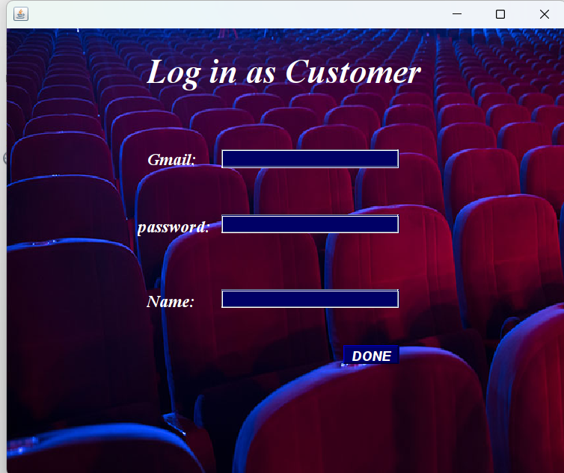

(Customer) frame is only for customers. In this frame, the customer will enter his name, his gmail, and password after create his own account, then click on the (Done) button to enter the cinema city application .

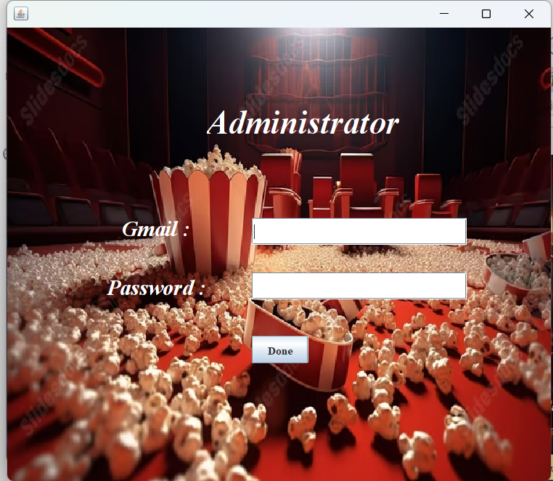

**Admins Registration**

(AdminLog) Frame

This frame is for admins only. The admin can login to his account by wirting his gmail and password in the textFields, then click on (Done) button to open the frames.

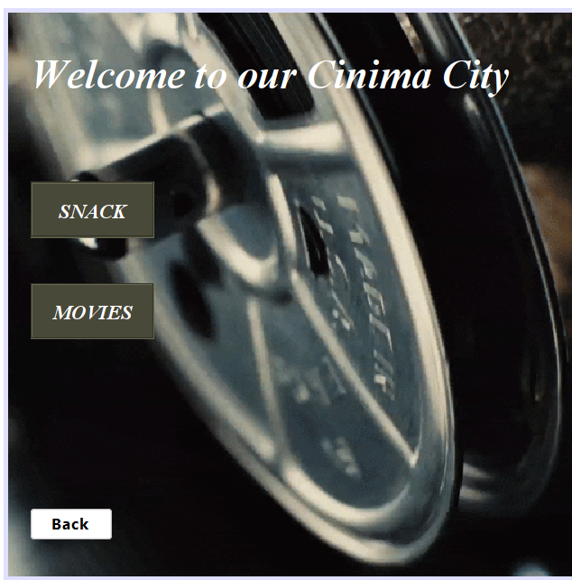

In this frame, the user can choose whatever he wants to know more information about, such as, type of movies available at the cinema, or types of snacks in the cinema

**Housed Frame**

(framm) Frame

1

**Movies frame**

(Type) Frame

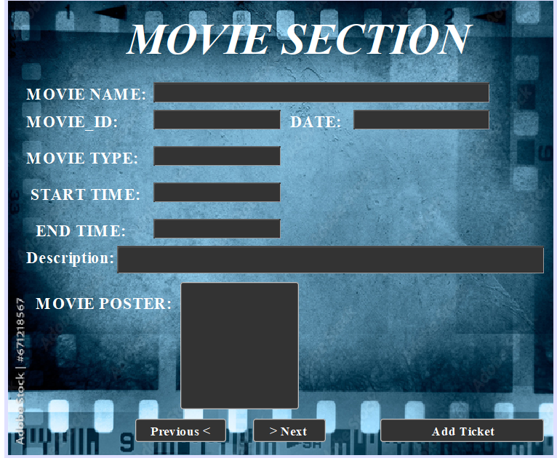In this frame, the user can search on any movie by click on (>Next) button or (<Previous) button to move between the available movies inside the cinema. All the data about the movie will appear in the uneditable text fields with the picture.

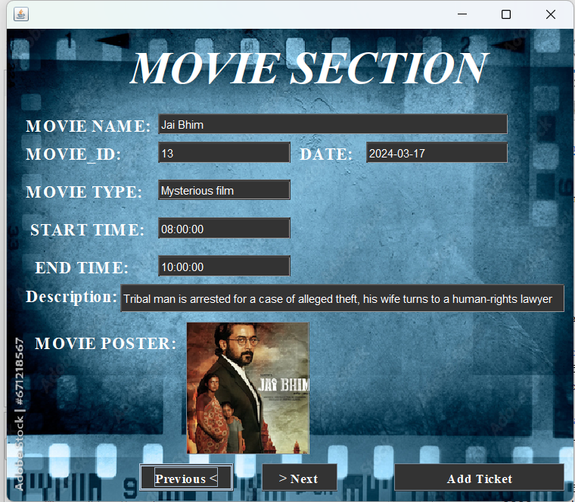

Mysterious Movies

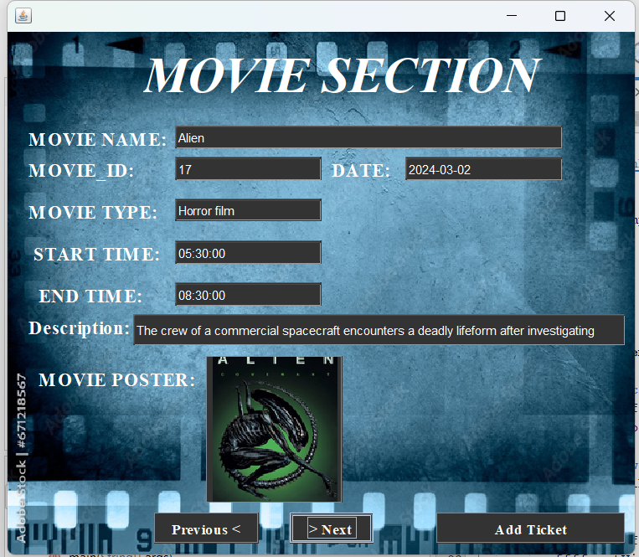

Horror Movies

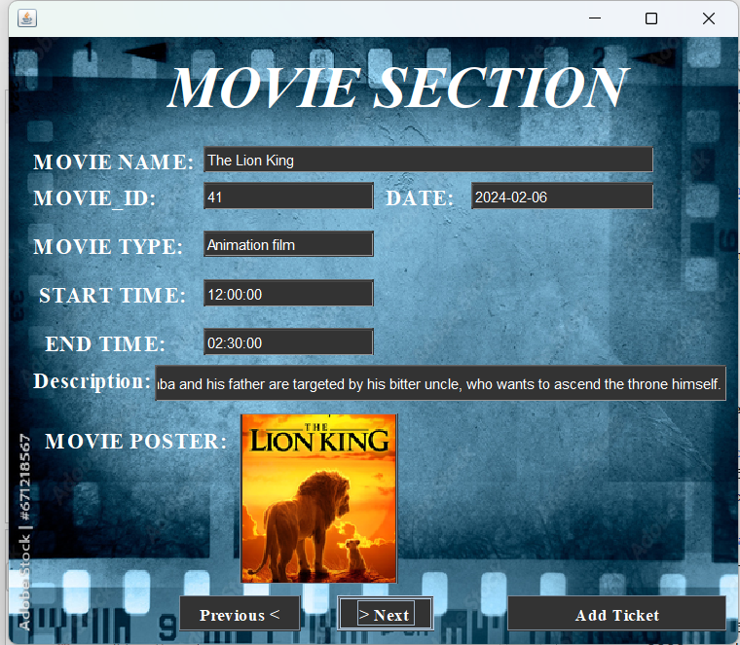

Animation Movies

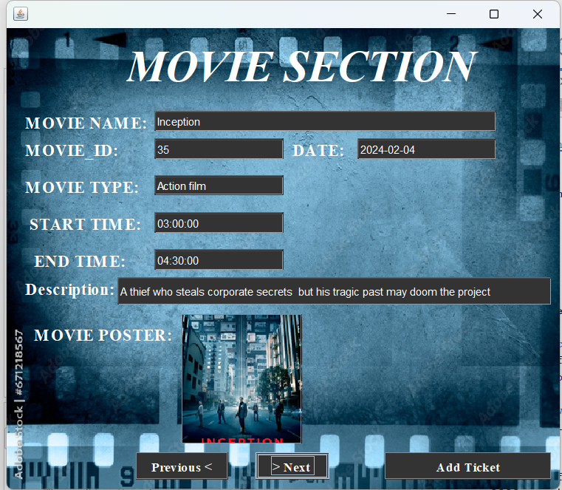

Action Movies

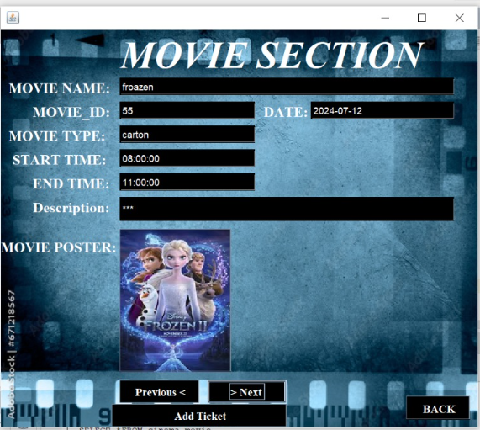

Disney Movies

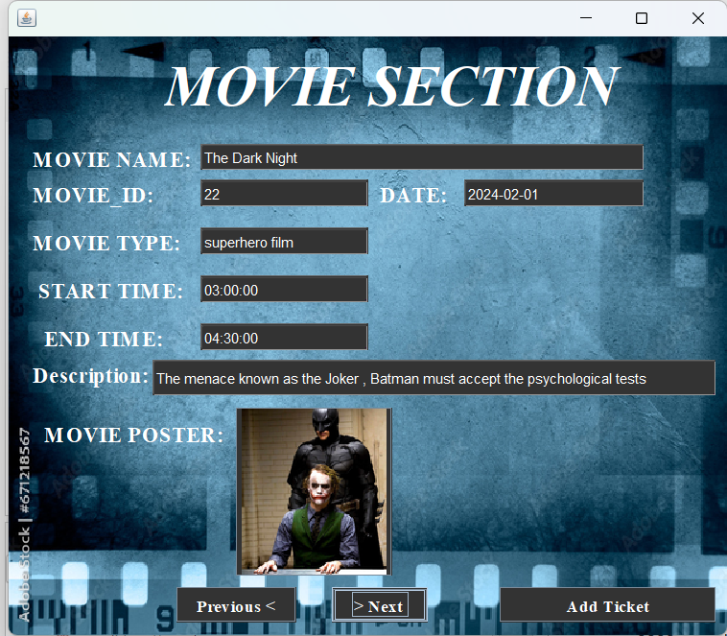

SuperHero Movies

When the user selects the movie he wants, he will click on (Add Ticket) to go to ticket frame.

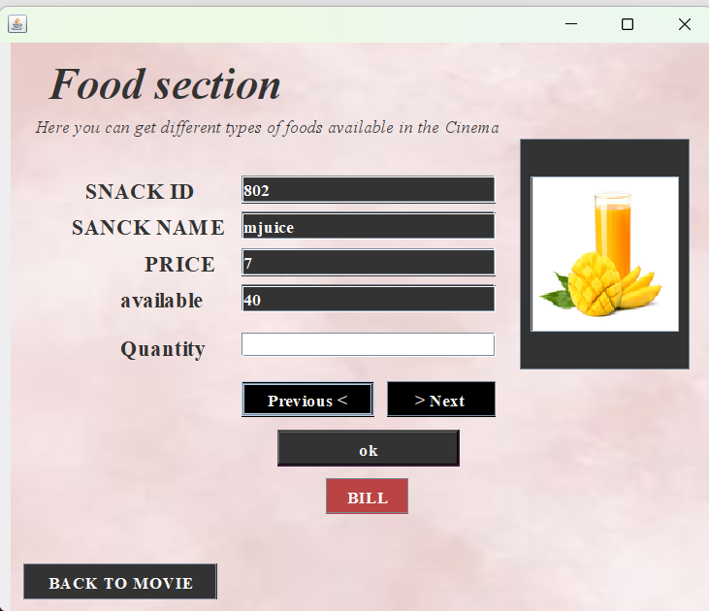

**Food List frame**

(food) Frame

In this frame, the user can see the available food and drinks. There are more than one type of juice, pizza and popcorn , the user can move between the types through by clicking on the (next >) or (previous <) button.

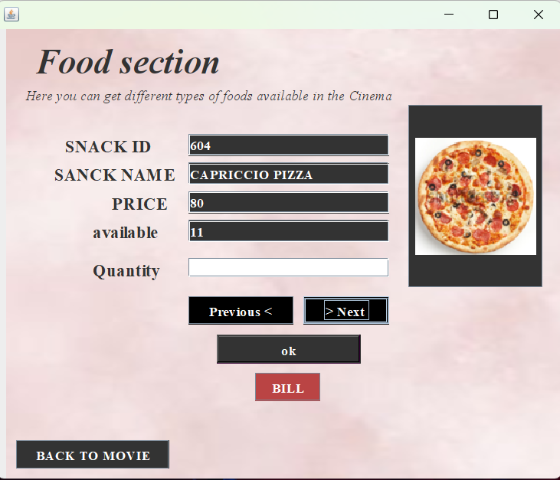

The price of each item differs from the other, as the price appears for each item separately .The user can choose the quantity he needs of each item by entering the value in (Quantity)

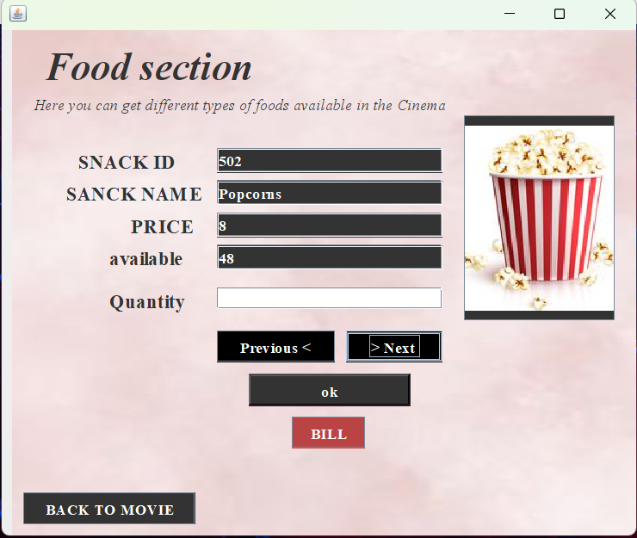

When the user presses the (OK ) button, the entered values are stored in the data base, and when the user presses on (BILL) button, it opens the bill frame to calculate the final price.

**Tickets frame**

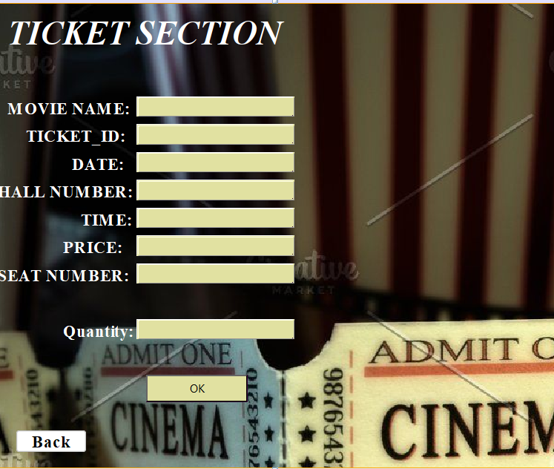 In (tickets) frame, **After selecting the movie in the Movie Section interface by pressing the (Add Tticket) button, this interface will appear and the information about the desired movie is added inside (text field movie name), (text field ticket id), (text field date), (text field hall number), (text field time), (text field price), (text field seat number), then he enters the number of tickets at (text field Quantity), then press the (Ok) button to move to Bill frame.**

**Output example :**

Here an example. The user (Dima)chooses a movie where the ticket price = (50$). she takes only one ticket, so the price becomes = (50$). Then she chooses a snack (popcorn) whose price is = (9$). In the bill frame, the total price for the user (Dima) is shown, where it = (59$)

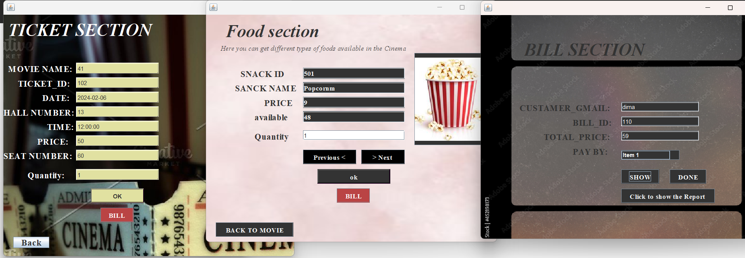

**Administrator Frames :**

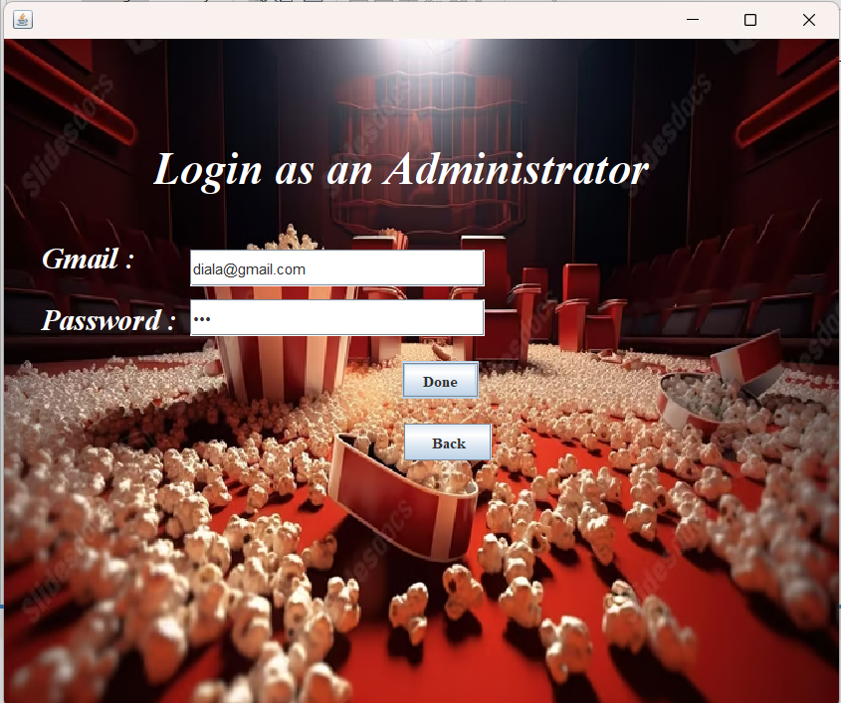 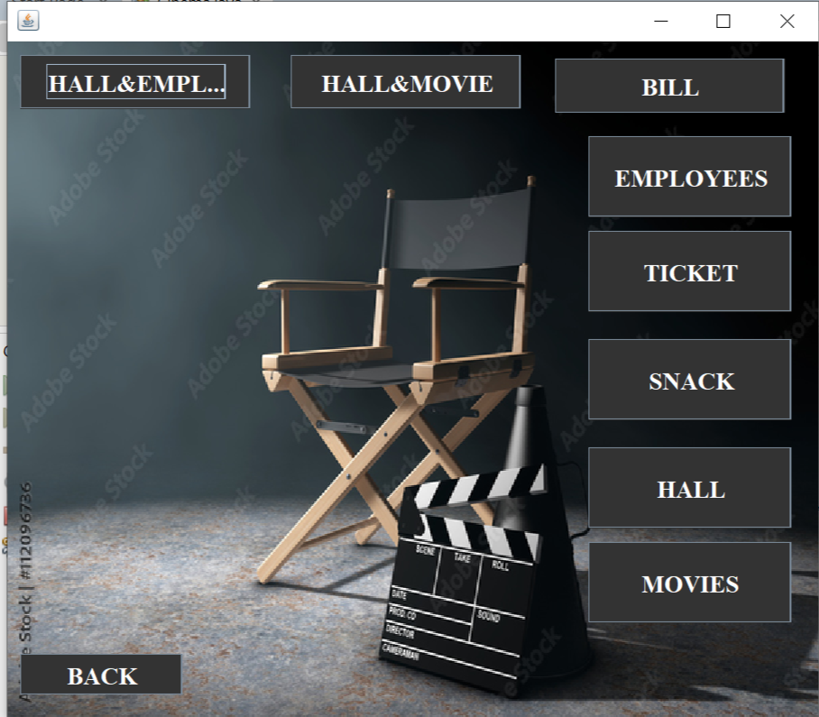

In this frame, the manager chooses the frame to be modified, deleted from, or added to

In this frame, we enter the Gmail of the managers (Diala and Yamama) only to move to the next frame.

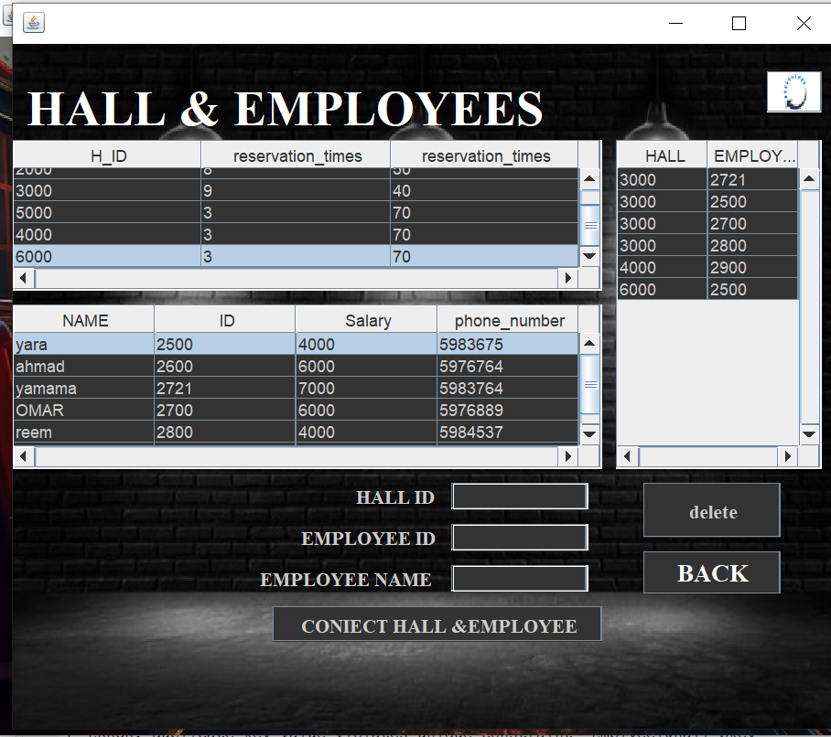

If the administrator chooses frame (Hall & Employee), he can delete a specific employee from the room number in which he works and modify the room number in which each employee works.

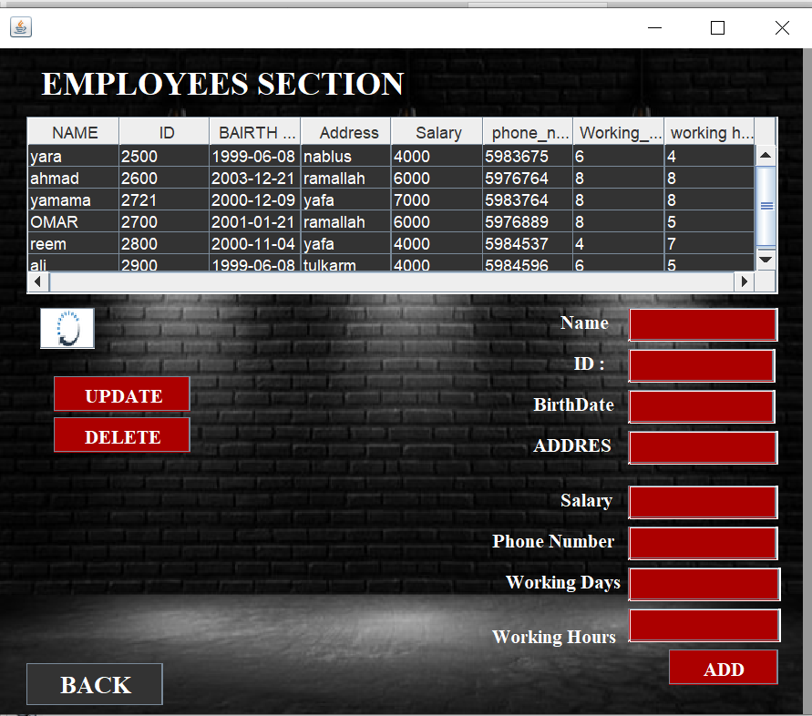

If the administrator chooses frame(Employee), he can modify the data of a specific employee, or delete all his information from the data base.

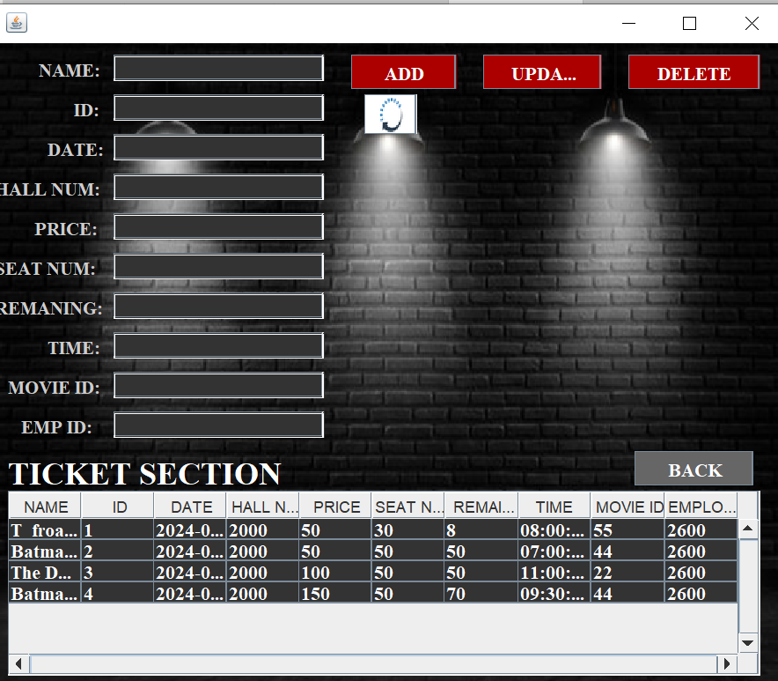

The administrator can add ticket for any movie , he can delete it also modify data for all tickets

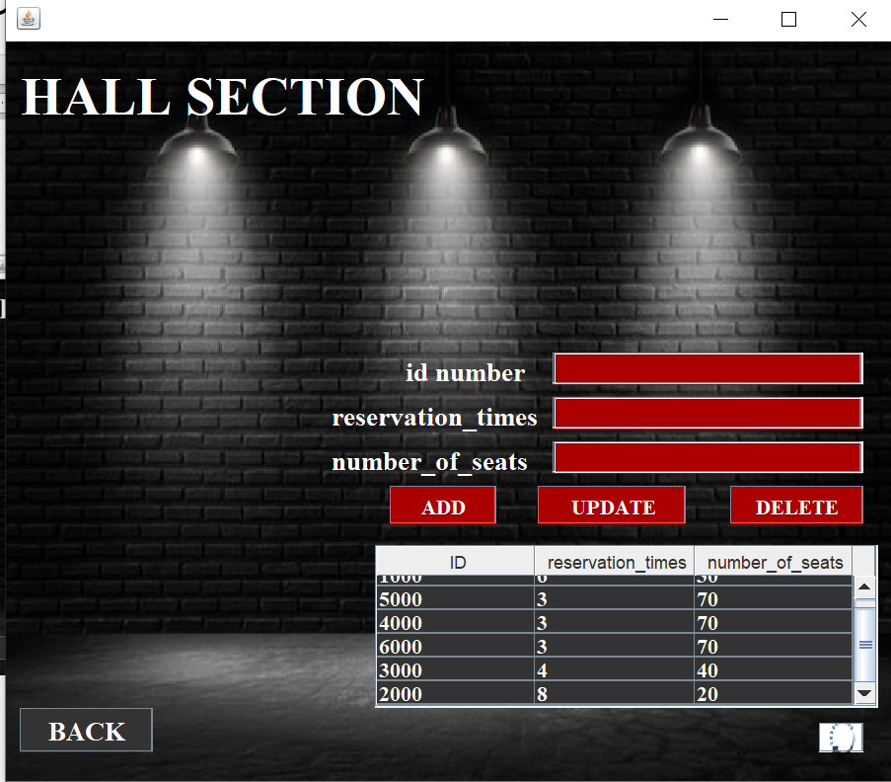

If the administrator chooses frame (Hall ), he can delete a specific room ,and modify the room time reservation in addition number of seats in each hall.

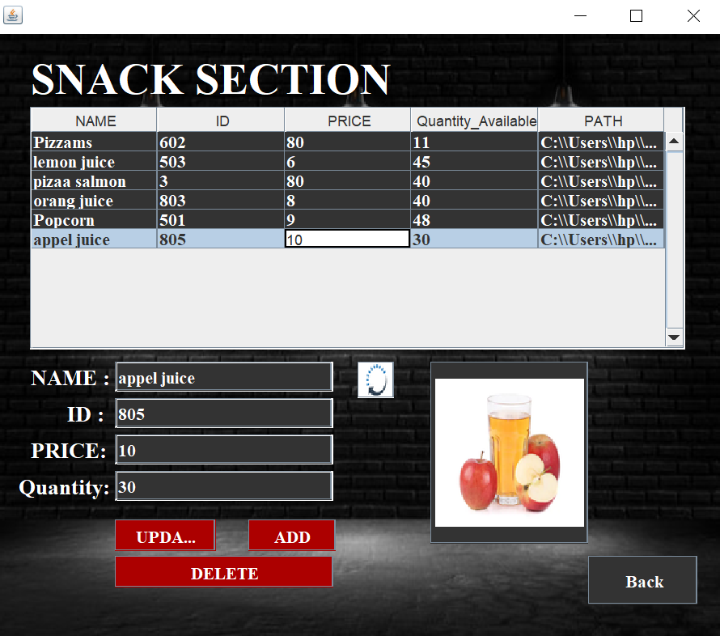

In this frame(snack), the administrator can search on any snack by click on (>Next) button or (<Previous) button to move between the available snack inside the snack tabel ,also he can click on tabel the information will display in text filds with the picture.

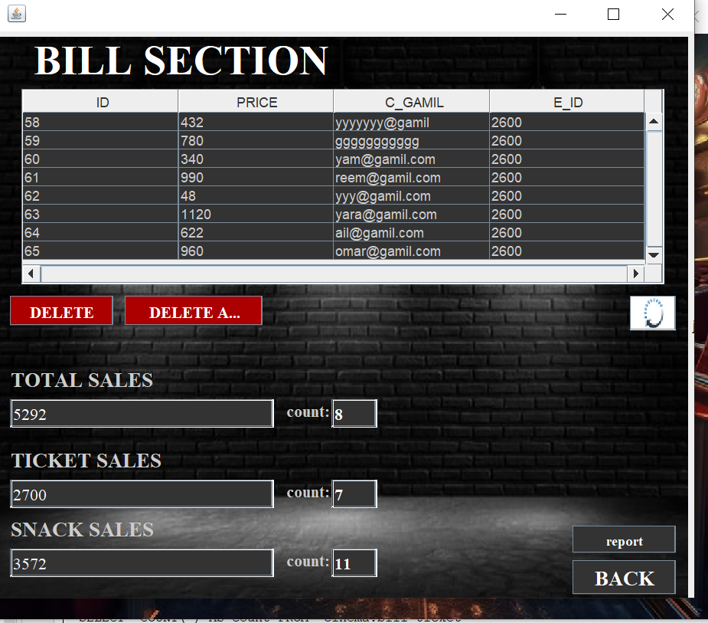

If the administrator chooses frame (bill),He can see all bills in cinema in addition some calculation about cinema sales ,their 3 important buttons delete ,delete all ,the last one to print report.

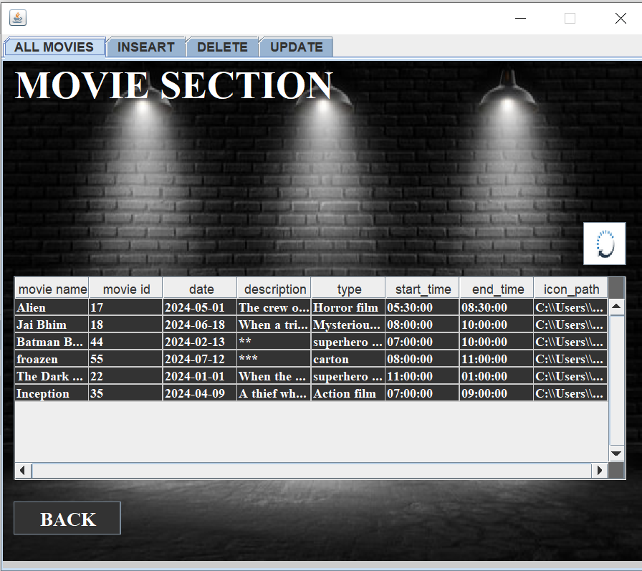

If the administrator chooses frame (movie),He can see all movies in cinema , insert tab, delete tab ,update tab.

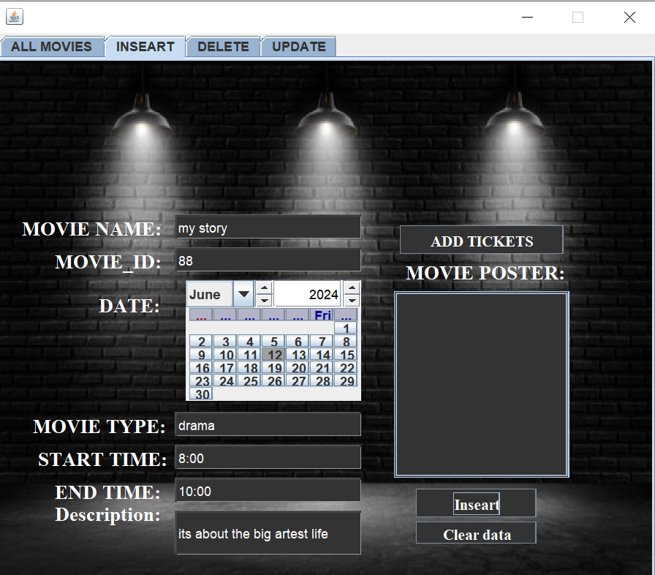

If the administrator chooses frame (insert tab)in (movie frame)

He can add movie to cinema ,with all information (time ,name, poster ,ticket …).

When (add ticket)clicked

The system will take some data information to ticket frame.

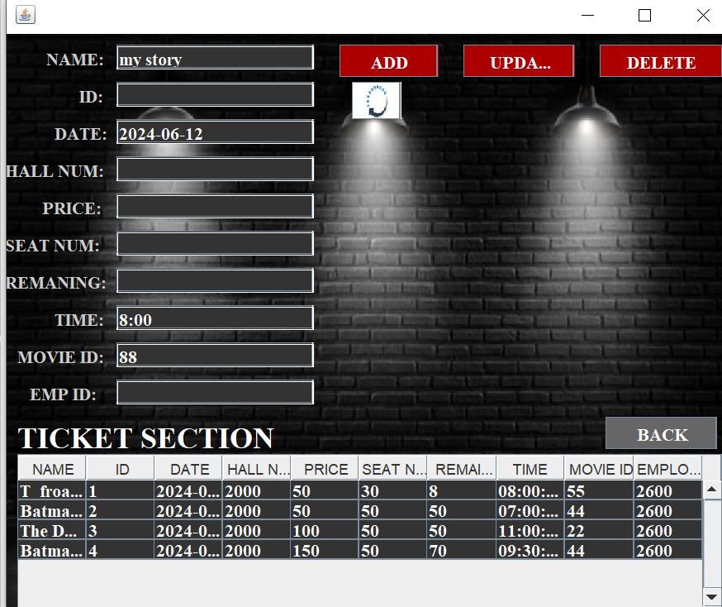

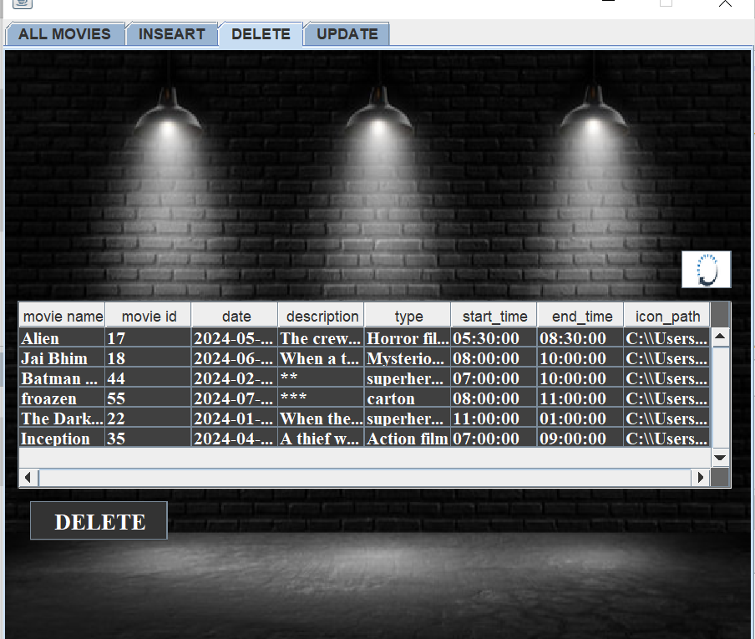

If the administrator chooses frame (delete tab)in (movie frame)

He can delete movie from cinema .

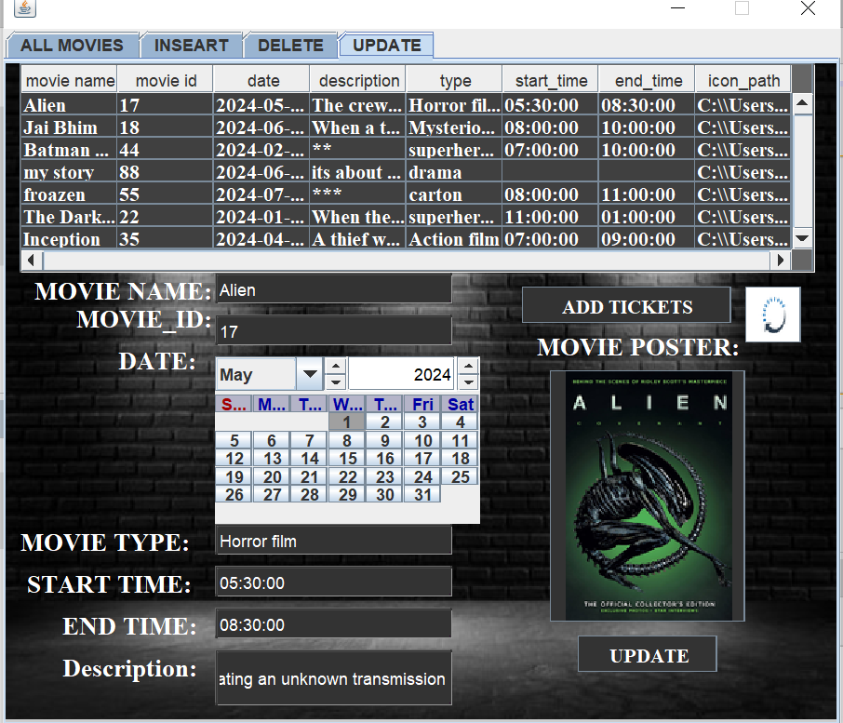

If the administrator chooses (update tab)in (movie frame)He can update information of any movie in cinema .

**1. Table: "EMPLOYEE"**

* **Functional Dependencies:**
  + **E_ID → E_name, Bdate, Address, Salary, phone_number, Working Days, working hours, A_gmail**

The primary key is E_ID. All non-trivial functional dependencies have the primary key on the left side. Therefore, it is in BCNF.

**2. Table: "Hall"**

* **Functional Dependencies:**
  + **H_ID → hall_reservation_times, number_of_seats**

The primary key is H_ID. All non-trivial functional dependencies have the primary key on the left side. Therefore, it is in BCNF.

**3. Table: "snack"**

* **Functional Dependencies:**
  + **S_ID → the_price, food_drink_name, Quantity_Available**

The primary key is S_ID. All non-trivial functional dependencies have the primary key on the left side. Therefore, it is in BCNF.

**4. Table: "custamer"**

* **Functional Dependencies:**
  + **C_gamil → name, c_pass**

The primary key is C_gamil. All non-trivial functional dependencies have the primary key on the left side. Therefore, it is in BCNF.

**5. Table: "movie"**

* **Functional Dependencies:**
  + **M_ID → M_name, date, description, type, show_time, start_time, end_time**

The primary key is M_ID. All non-trivial functional dependencies have the primary key on the left side. Therefore, it is in BCNF.

**6. Table: "tiket"**

* **Functional Dependencies:**
  + **T_ID → T_name_of_movie, date, hall_num, price, seat_num, remainig_num, time, M_ID, E_ID, C_ID**

The primary key is T_ID. All non-trivial functional dependencies have the primary key on the left side. Therefore, it is in BCNF.

**7. Table: "Bill"**

* **Functional Dependencies:**
  + **b_id → total_price, c_id, e_id**

The primary key is B_ID. All non-trivial functional dependencies have the primary key on the left side. Therefore, it is in BCNF.

**8. Table: "Emplyee1&hall"**

* **Functional Dependencies:**
  + **E_ID2, H_ID2 → (no further functional dependencies based on provided information)**

The primary key is composed of both E_ID2 and H_ID2. All non-trivial functional dependencies have the primary key on the left side. Therefore, it is in BCNF.

**9. Table: "hall&movie"**

* **Functional Dependencies:**
  + **H_ID2, M_ID2 → (no further functional dependencies based on provided information)**

The primary key is composed of both H_ID2 and M_ID2. All non-trivial functional dependencies have the primary key on the left side. Therefore, it is in BCNF.

**10. Table: "tiket&cusamer"**

* **Functional Dependencies:**
  + **T_ID2, C_ID2 → (no further functional dependencies based on provided information)**

The primary key is composed of both T_ID2 and C_ID2. All non-trivial functional dependencies have the primary key on the left side. Therefore, it is in BCNF**.**

**11. Table: "bill&snack"**

* **Functional Dependencies:**
  + **B_ID2, S_ID2 → (no further functional dependencies based on provided information)**

The primary key is composed of both B_ID2 and S_ID2. All non-trivial functional dependencies have the primary key on the left side. Therefore, it is in BCNF.

**12. Table: "Admain"**

* **Functional Dependencies:**
  + **A_gmail → A_pass**

The primary key is A_gmail. All non-trivial functional dependencies have the primary key on the left side. Therefore, it is in BCNF.

**Conclusion**

Cinema City project is user-friendly. It allows customers to observe the new movies, the coming soon ones, and the tickets available at the cinema. It also observe the drinks and food available, with the type of each one of them, the price, and the available amount. So, customers can know all the needed information from the frames and from the report.

**References**

* <https://www.rapidtables.com/web/color/RGB_Color.html>
* <https://www.youtube.com/watch?v=YxCm49O4zt8>
* <https://www.youtube.com/watch?v=qGZMrRdE1Wc>
* <https://stackoverflow.com/questions/30229991/netbeans-database-retrieve-data-and-display-it-another-jframe-textfield>
* <https://community.jaspersoft.com/wiki/build-jasper-report-using-jasper-library-using-net-beans-ide>
* <https://www.youtube.com/watch?v=RqHr3dMCF7s&feature=youtu.be>
* <https://www.youtube.com/watch?v=l0gbdpxXbcQ&feature=youtu.be>
* <https://app.grammarly.com/ddocs/820068474>
* <https://www.youtube.com/watch?v=3rSRP5WUlM8&feature=emb_logo>
* <https://www.youtube.com/watch?time_continue=2&v=TwMXA1S38qg&feature=emb_logo>